Clinical System Test Cases

By Mohammad Hamo : 1230394 / Yanal Omar :1230156

Test Case 1 : adding to the clinical System

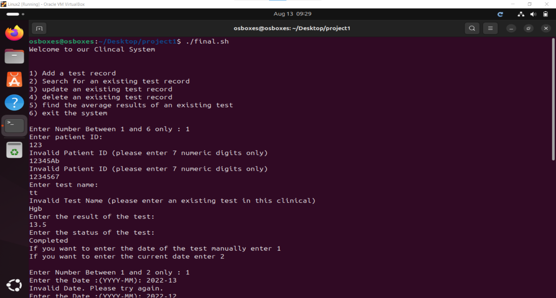

This is the Main menu it shows what you can do with this system

For example we wanted to add a new medical record so we enterd 1

1)We tried to enter wrong format for the patient id and the system refused i

So when we entered the correct form for it it accepted it and asked the user to enter the remaining details (and the same will be for the testName)

(if we added the same information (ID,testName,testDate) the system will tell you that there is already a person with these information )

2) when it comes to date the system gives the user two choices either to enter the date manually ( and it will check if its in the correct form and a valid date ) or the system will enter the date automatically due to the current date

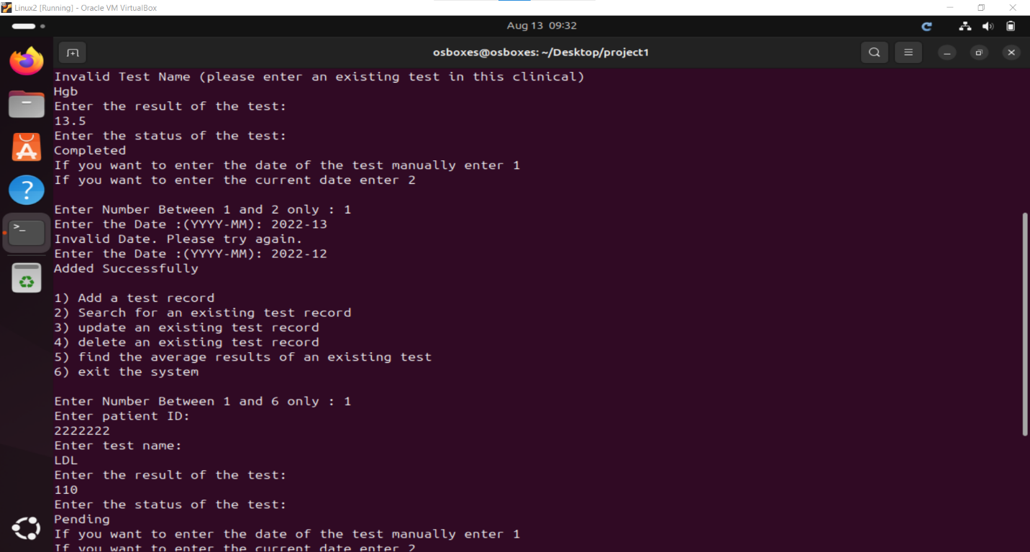look how when the user entered 2022-13 it refused it

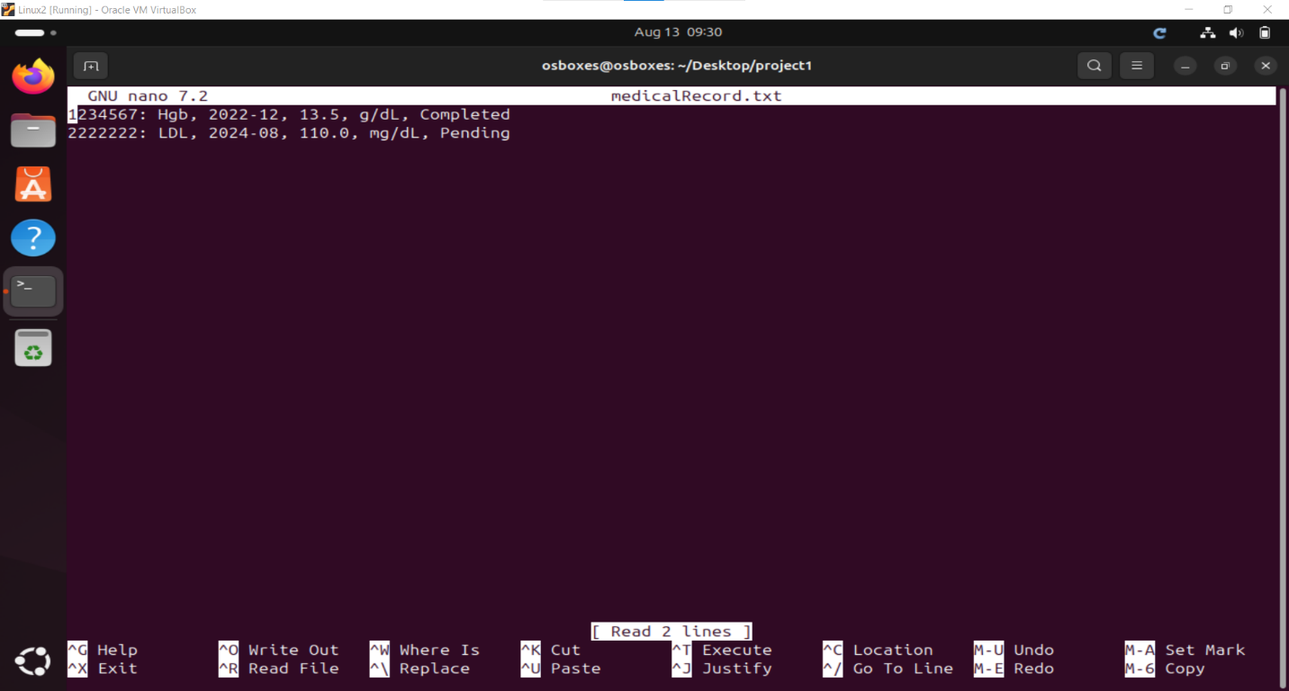this is the medical record After we added the two users

Test Case 2: